**iOS/iPadOS Quick Start End User Guide and FAQs**

# Contents

Contents 1

1.Editing this document 1

2. Document Overview 1

2.1 A note on Device Variations 1

3. Getting Started on iOS (Single User) 2

4. Getting Started on iOS (Shared Devices) 27

4. iOS/iPadOS Frequently Asked Questions (FAQs) 41

6. Details of Organisation-specific Support 43

# 1.Editing this document

This document has been produced to support End Users to enrol their devices and to support simple technical troubleshooting. The content detailed is correct as of 01/07/21 and represents the most likely series of steps End Users will have to complete. This document is editable so you can make the content specific to your organisation if you wish. For example, depending on the technical infrastructure at your organisation, there may be additional steps which end users need to complete. Editing the document may also increase End User engagement.

If you do edit this document, please be aware of the following as outlined in the Mobile Devices Early Adopter Requirements Document: ‘*if any LA / End User communications and / or guidance materials are edited by an organisation to suit the specificities of their own context, this is done at the organisation’s own risk*.’

# 2. Document Overview

This Quick Start End User Guide and FAQs document is intended to be used by End Users at [*Organisation*] who will be using iOS devices enrolled onto Intune. The step-by-step enrolment processes detailed in this guide should be followed by End Users with either iPhones or iPads.

This Quick Start User Guide covers the steps which need to be followed to enrol both Single User and Shared User devices. Please use the content to navigate to the specific steps you will need to follow.

The iOS FAQs provide a list of commonly asked questions with suggested courses of action to support simple technical troubleshooting.

If you have questions or queries about any of the content in this document please contact your Local Administrator (LA). Local Administrator details / a mailbox address for end users at [*Organisation*] is provided at the end of this document.

## 2.1 A note on Device Variations

Please be aware that the enrolment steps outlined in this document may vary depending on the specific settings which Local Administrators will have applied to your device as part of the Apple Setup Assistant. The enrolment process should not vary considerably, but individual screens my differ slightly.

If you are unsure about whether to proceed with a step that is not in this guide, please contact your Local Administrator.

# 3. Getting Started on iOS (Single User)

**Step 1**

Unbox your device, plug it in and turn it on. Tap the home button or screen (depending on your device)

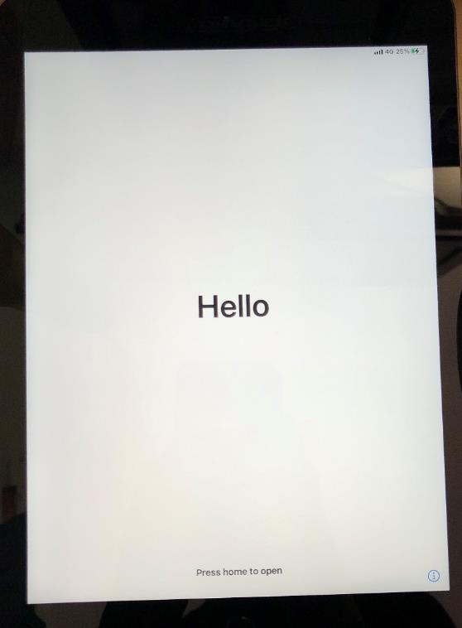

**Step 2**

Select ‘English’ as your language.

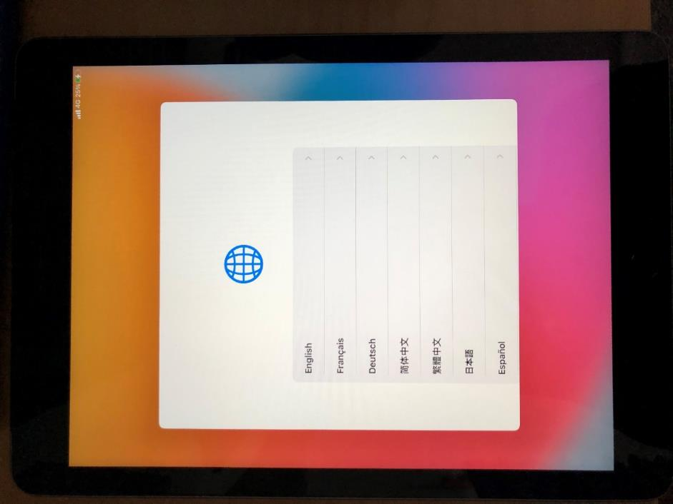

**Step 3**

Select ‘United Kingdom’ as your region.

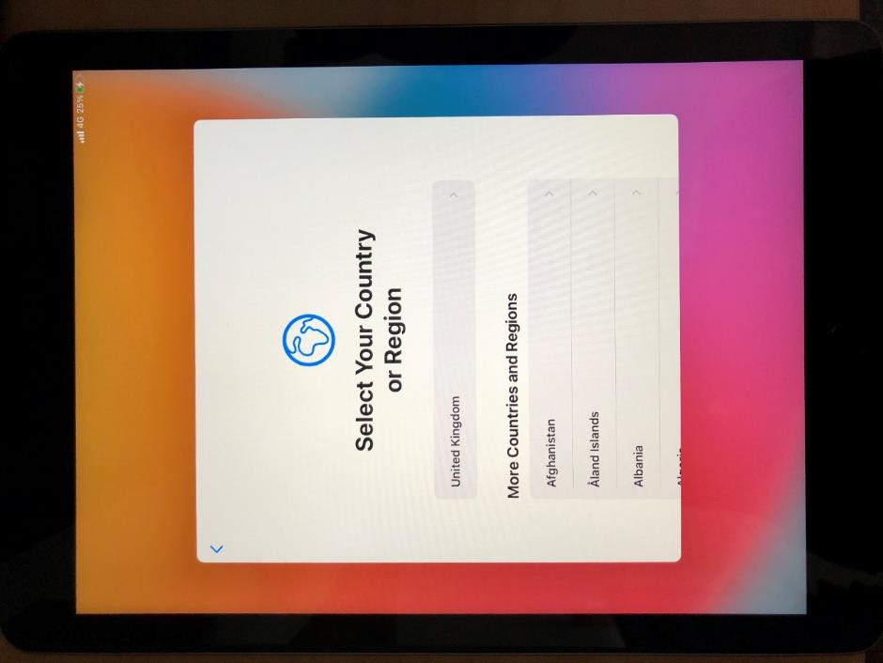

**Step 4**

You will be taken to a Quick Start Page. Select ‘Set Up Manually’.

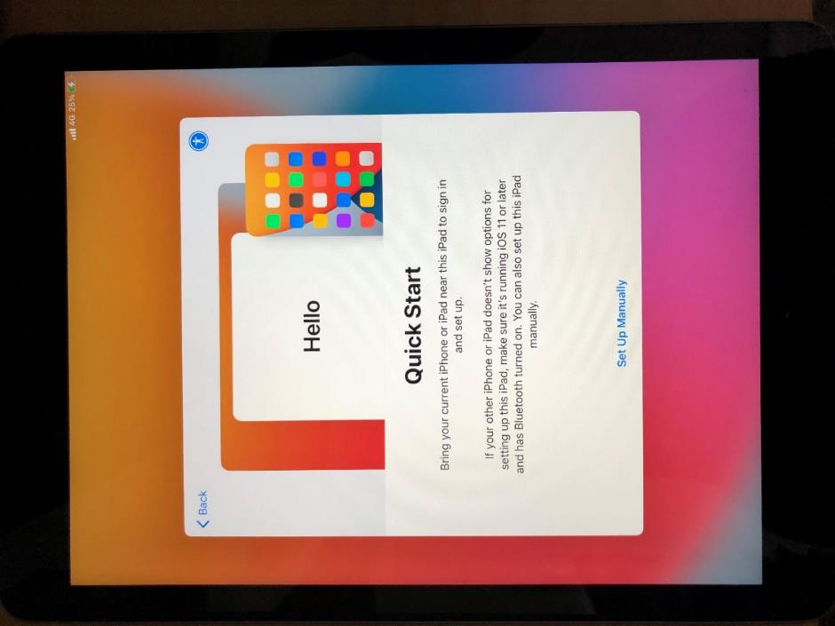

**Step 5**

Select the Wi-Fi network you wish to connect to from the list shown.

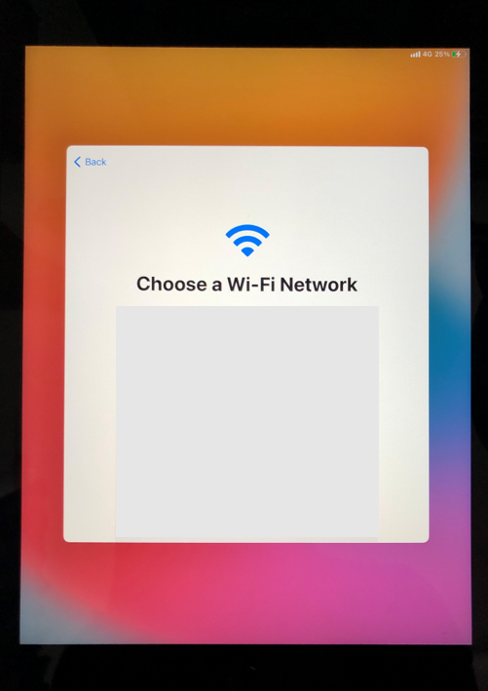

**Step 6**

Please read the Data and Privacy notice. Select ‘Continue’ if you are happy to progress past this notice or select ‘Learn more’ if you wish to know more.

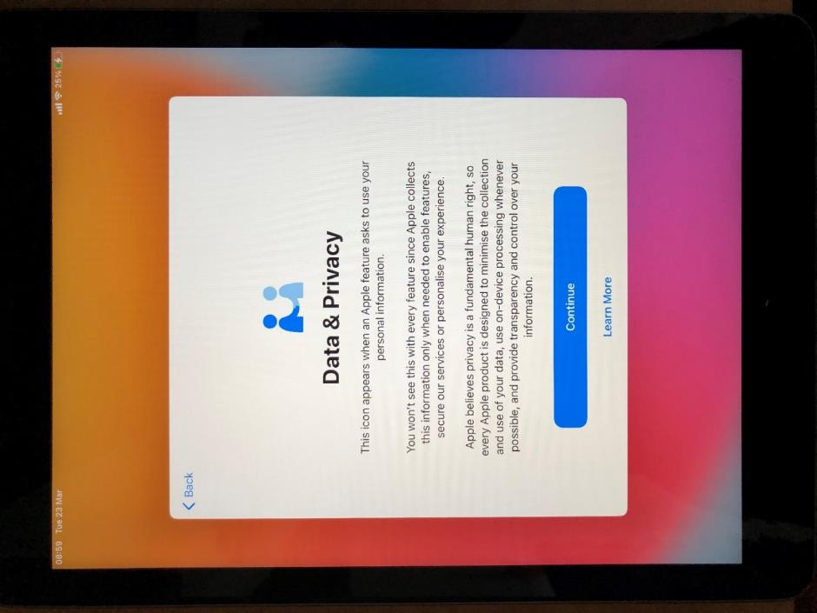

**Step 7**

You will be asked how you would like to configure your device. If you are a new user, you should select ‘Don’t Transfer Apps & Data’.

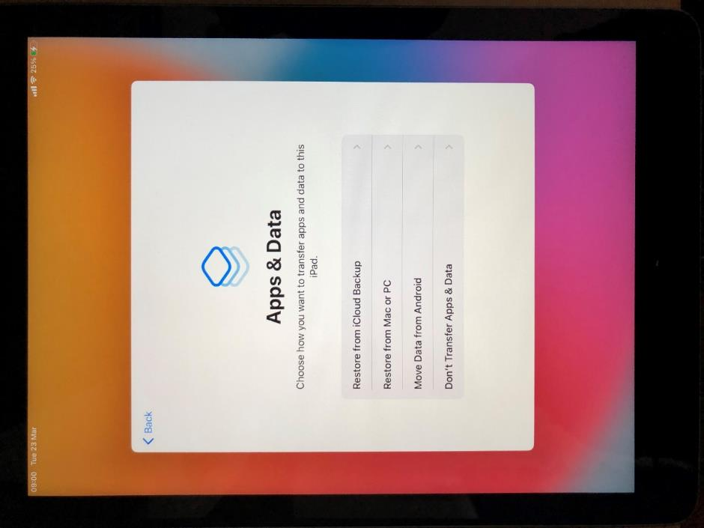

**Step 8**

You will be informed that your device will be managed by NHS Digital. If you wish, you can select ‘About Remote Management’ to learn more. If you are happy with the information provided on the screen, you can simply select ‘Next’ to progress with enrolment.

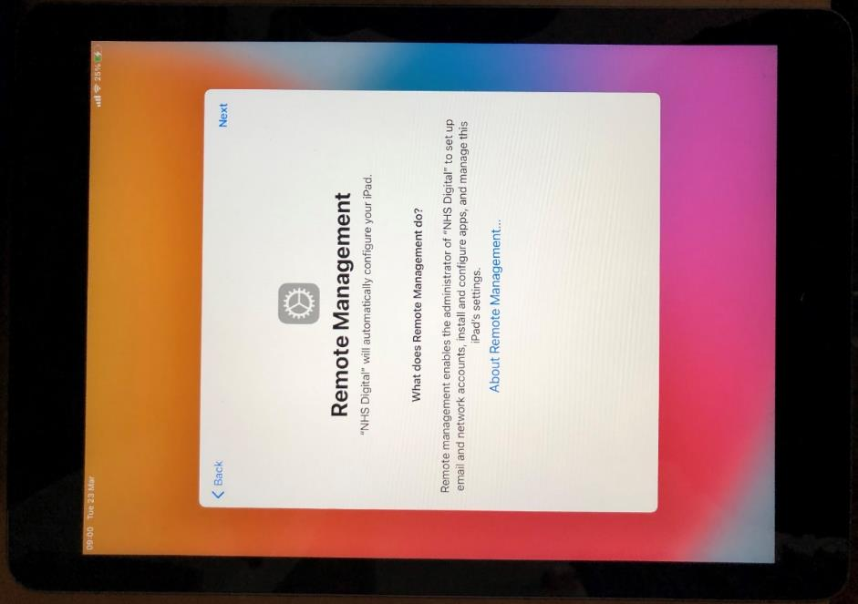

**Step 9**

Please wait while NHS policies are deployed onto your device. This may take a couple of minutes.

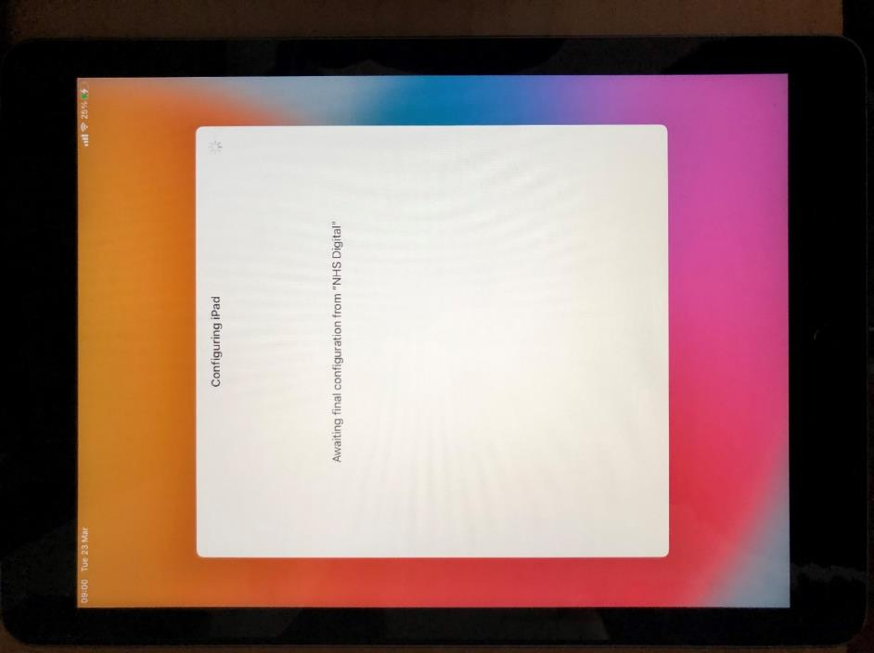

**Step 10**

You will be asked if you want to set up biometric authentication on your device. Select ‘Continue’ if you would like to do this or select ‘Set up Touch ID Later’ if you’d like to return to this at another time.

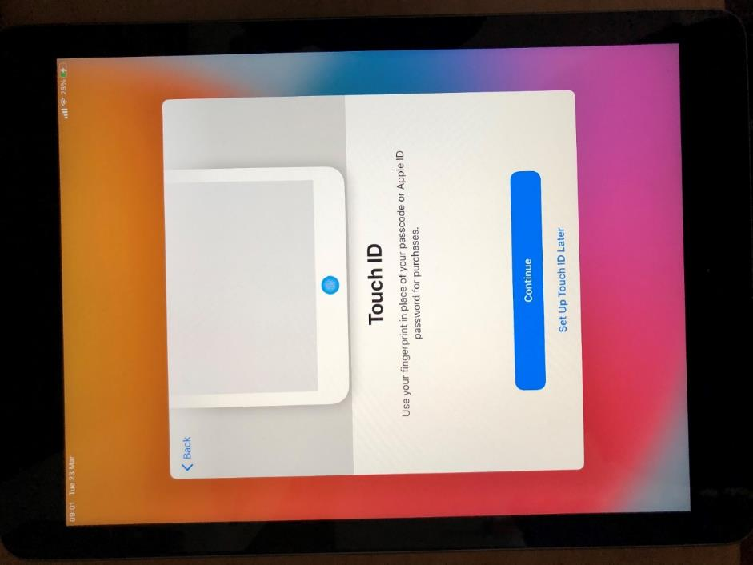

**Step 11**

You will be asked to set up a device passcode to help secure your device. Please enter a 6-digit passcode.

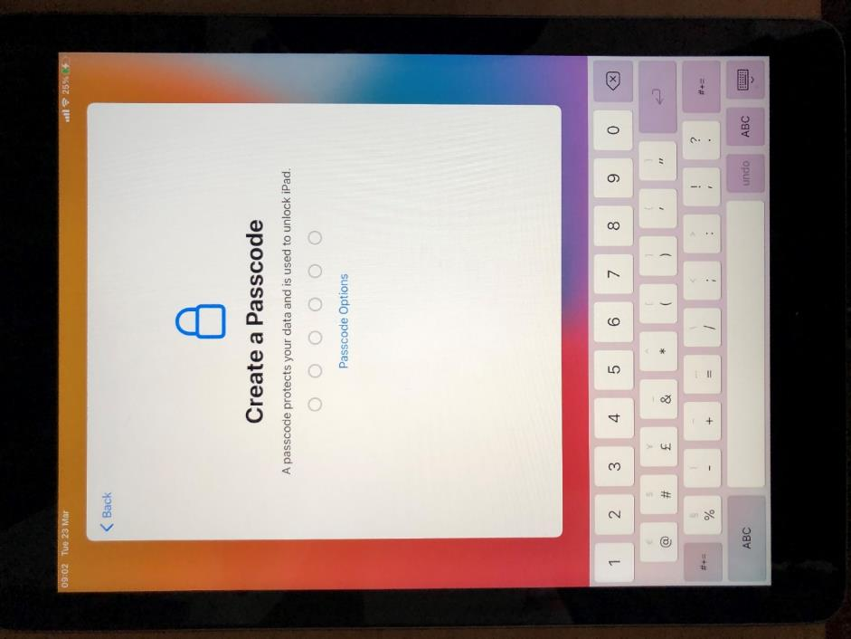

**Step 12**

Please read the Apple Terms and Conditions and select ‘Agree’ if you understand all terms and are happy to adhere to these.

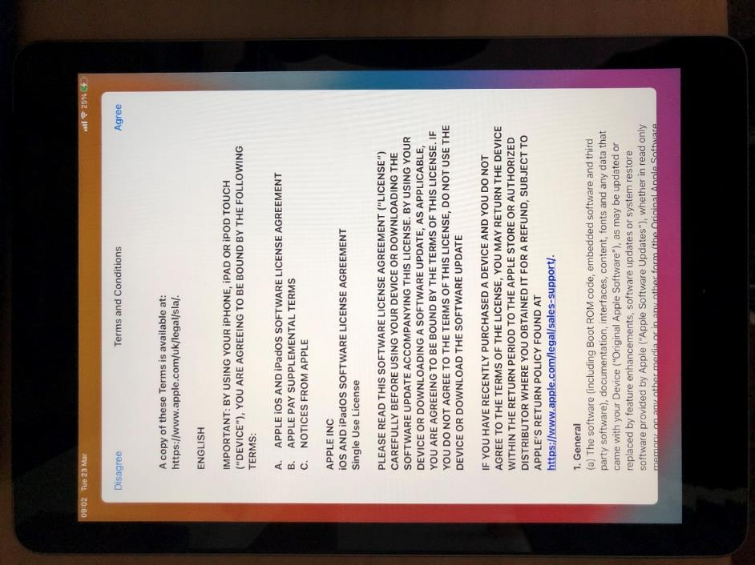

**Step 13**

Your device will now attempt to install any recent updates. Select ‘Continue’ to permit this and progress with the enrolment.

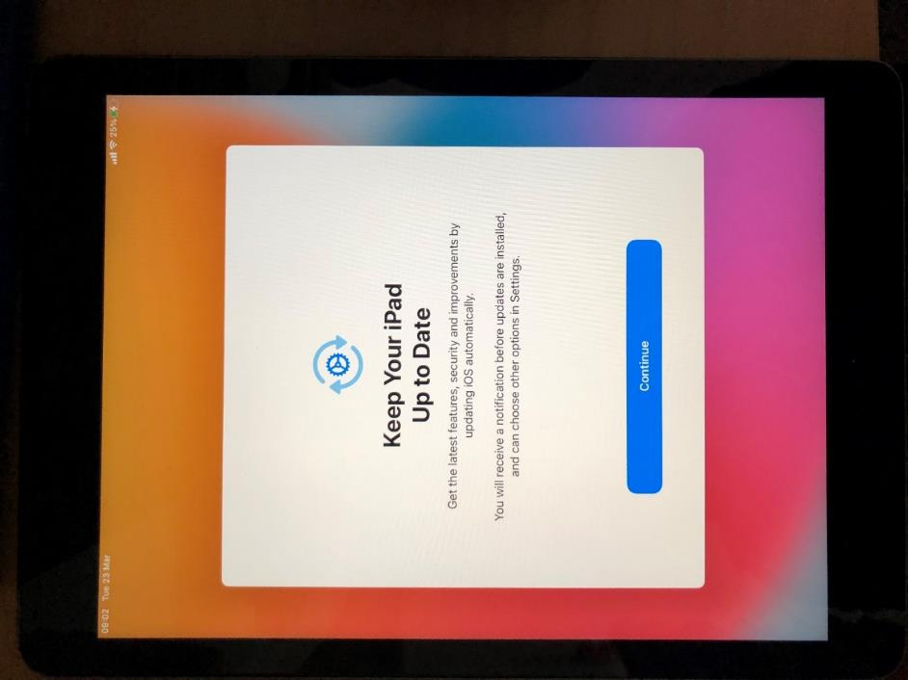

**Step 14**

You will be asked to configure Location Services. You should select ‘Enable Location Services’ to allow the device to configure the correct time zone.

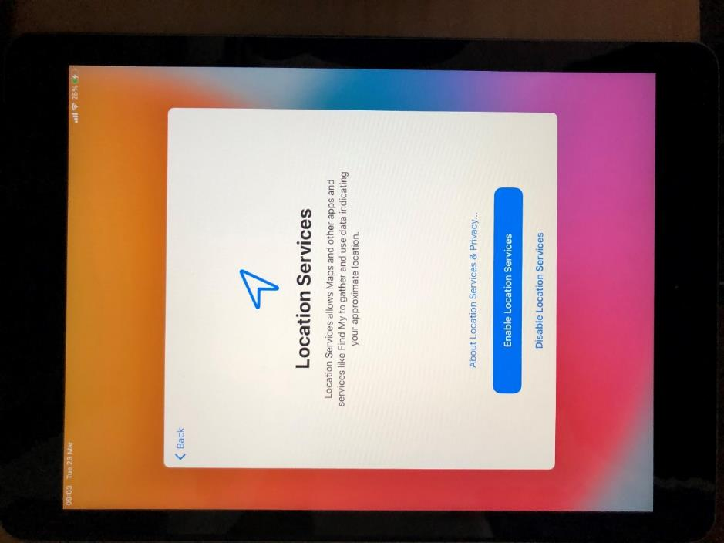

**Step 15**

Your device will provide you with the option of setting up Siri. This is entirely optional.

Select ‘Continue’ if you would like to set up Siri on your device or select ‘Set Up Later in Settings’ if you would like to move on from this screen and progress with the enrolment.

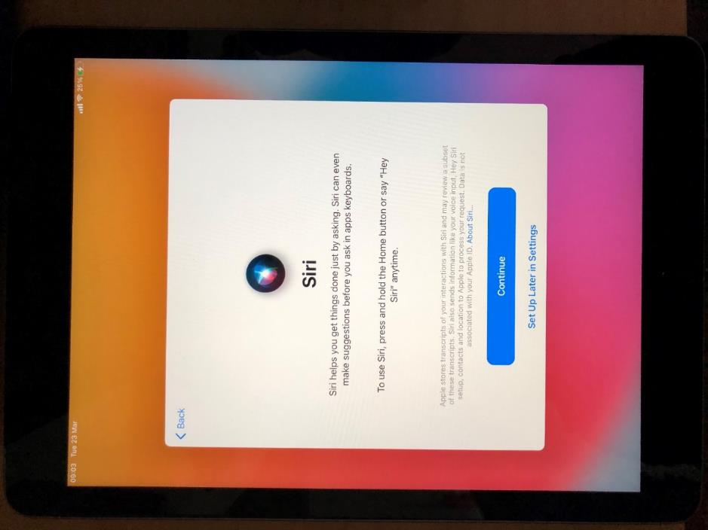

**Step 16**

Your device will provide you with the option to enable Screen Time. This is entirely optional.

Select ‘Continue’ if you would like to set up Screen Time on your device or select ‘Set Up Later in Settings’ if you would like to move on from this screen and progress with the enrolment.

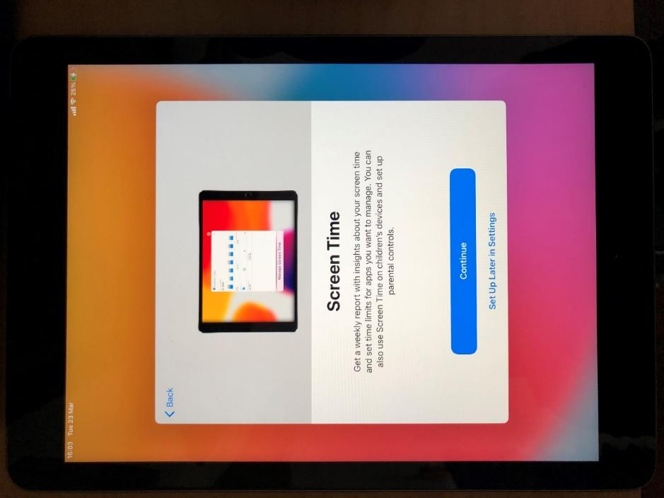

**Step 17**

Your device will provide you with the option to enable iPad Analytics. This is entirely optional.

Select ‘Share with Apple’ if you are happy for information about usage data to be shared with Apple. Select ‘About Device Analytics & Privacy’ if you would like more information about iPad Analytics. Select ‘Don’t Share’ if you would prefer not to share information about usage data with Apple.

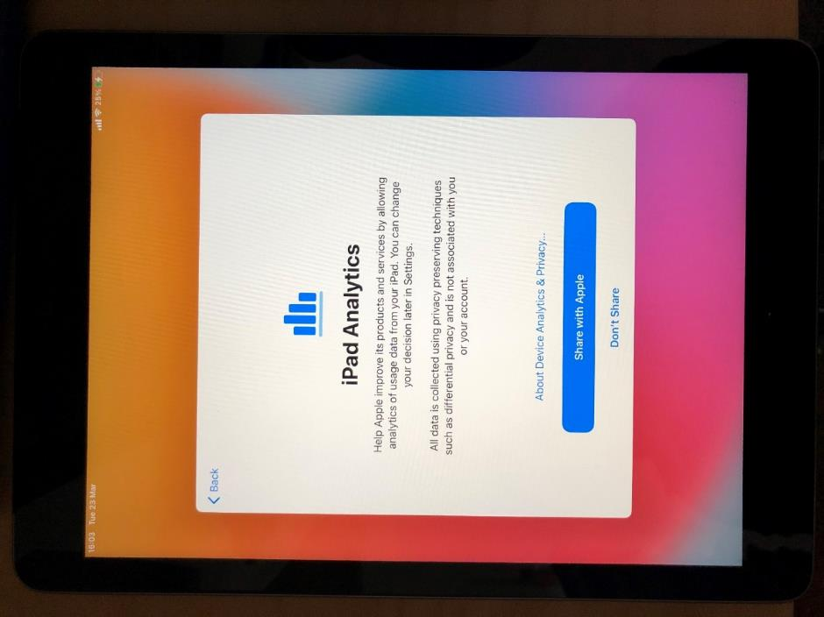

**Step 18**

You will be asked to select the appearance of your device’s screen. Choose either ‘Light’ or ‘Dark’ and select ‘Continue’ to progress with the enrolment.

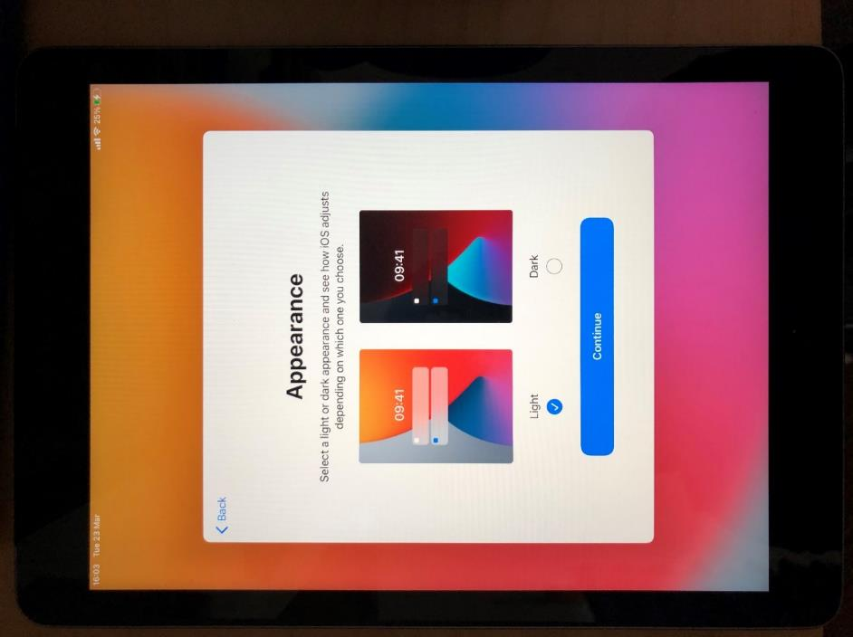

**Step 19**

Once Apple Set up has completed, you will be prompted to select the ‘Get Started’ button. Please select ‘Get Started’ to progress with the enrolment.

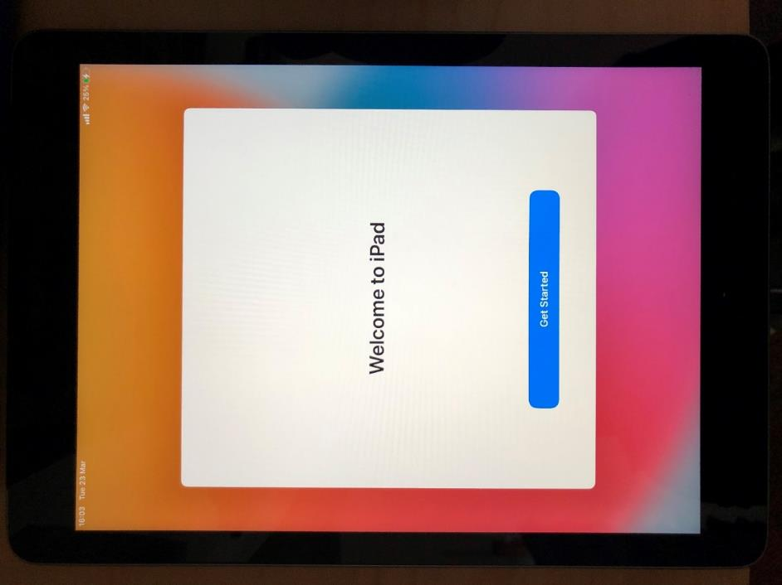

**Step 20**

Your device will now turn on again, but it will be in Guided Access mode while the Company Portal app installs in the background. Please be patient at this step, as it may take a couple minutes for the Company Portal app to install.

**IMPORTANT NOTE**: While your device is in Guided Access Mode, you will be unable to use the device screen or buttons until the device has enrolled into Intune.

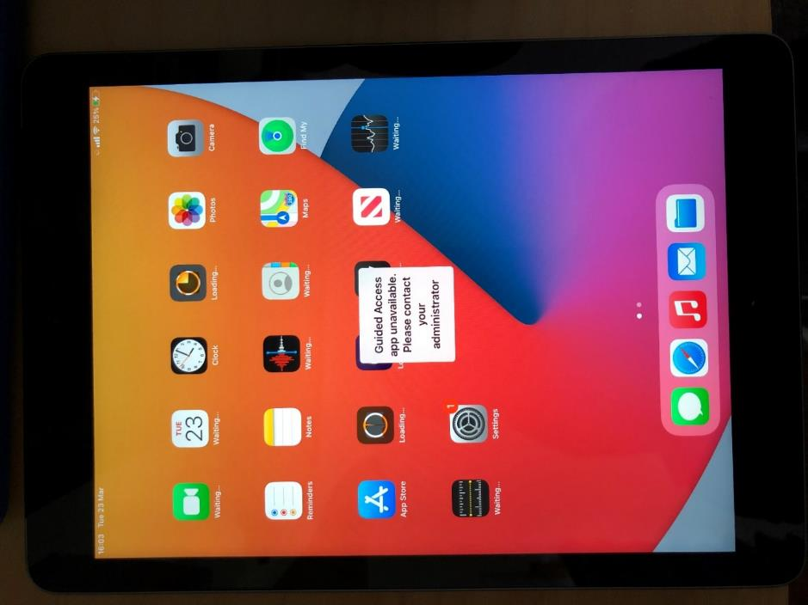

**Step 21**

You will now be prompted to sign into the Company Portal App. Select ‘Sign In’ to begin this process.

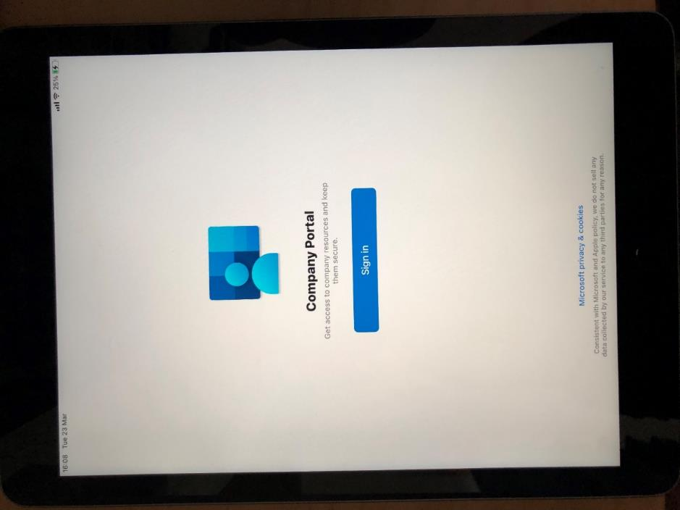

**Step 22**

To sign in, you will need to enter your nhs.net email address. Enter your nhs.net email address and select ‘Next’ to progress with the enrolment.

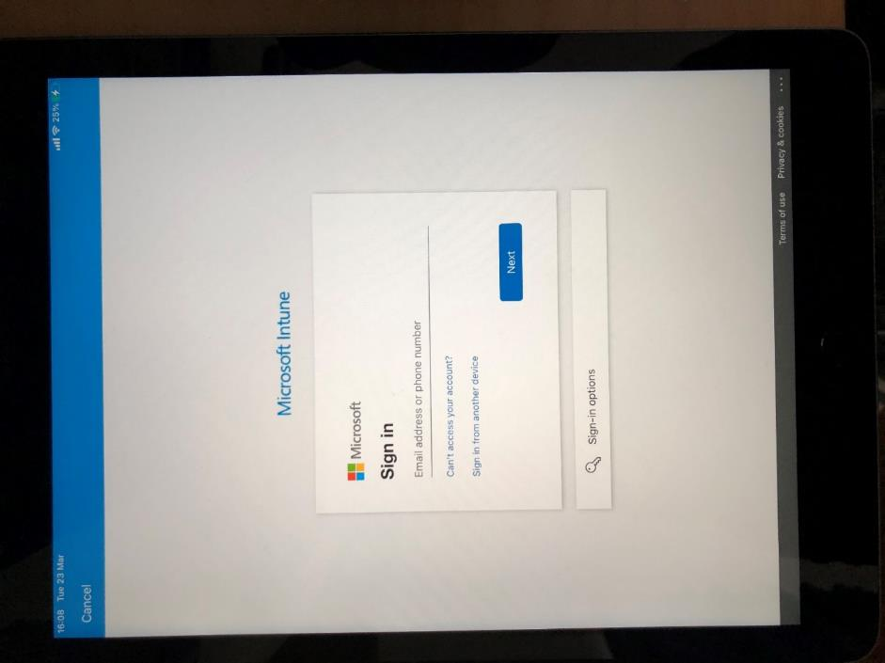

**Step 23**

You will now need to enter your nhs.net email password. Please enter this password and then select ‘Sign In’.

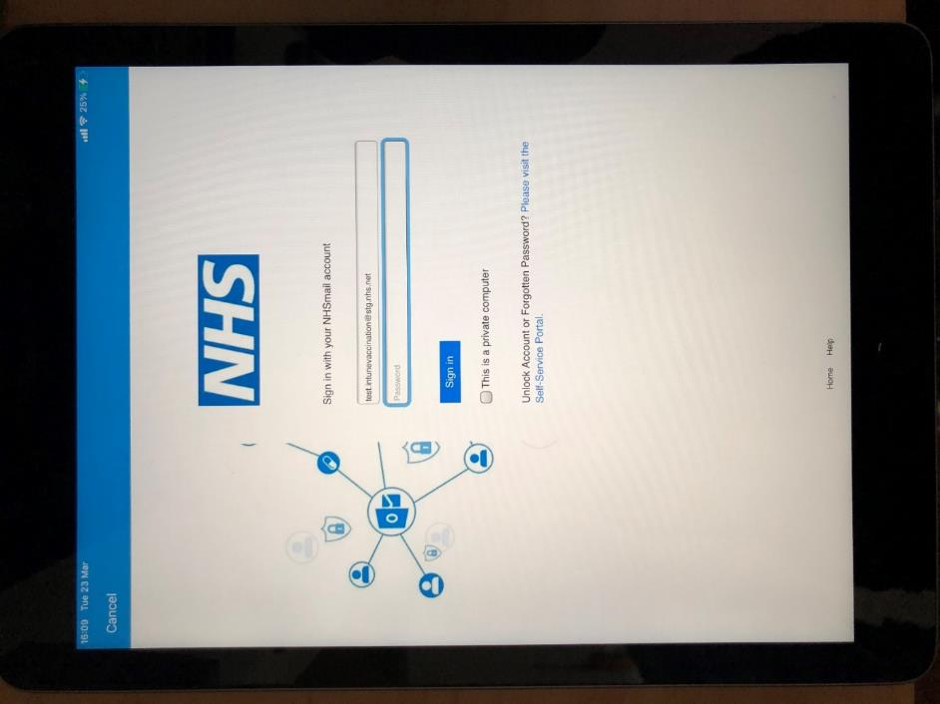

**Step 24**

If you have entered the correct nhs.net credentials you will see the screen below. Select ‘Done’ to progress with the enrolment.

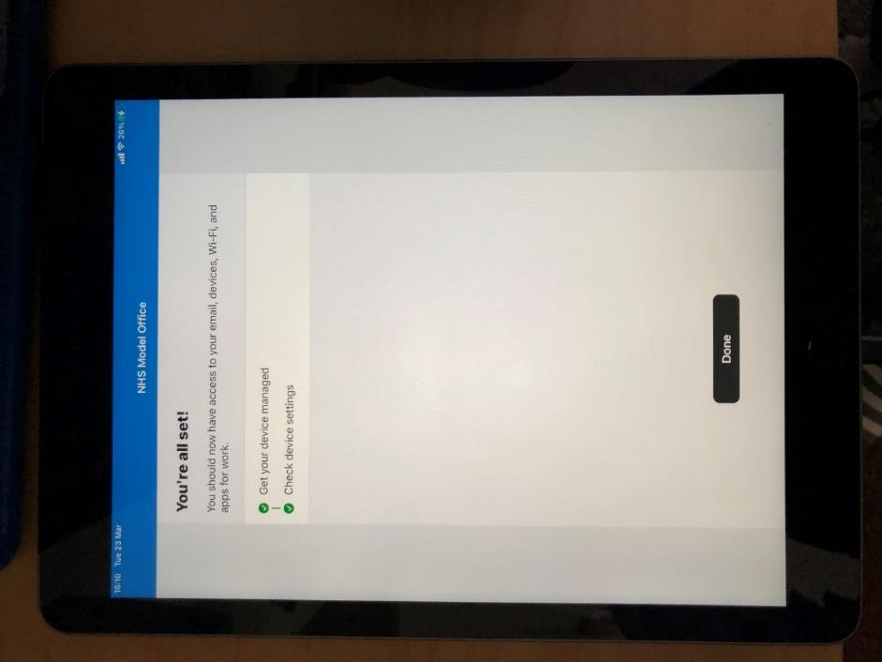

**Step 25**

Your device should now be enrolled into Intune. Guided Access mode should have been disabled and you should be able to use your device as you normally would.

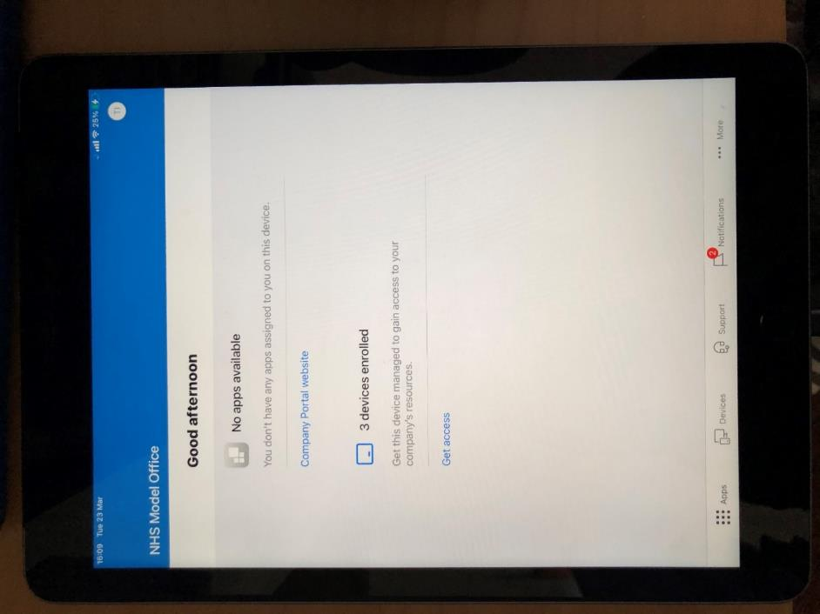

# 4. Getting Started on iOS (Shared Devices)

**IMPORTANT NOTE**: Be mindful that you are using a **shared device**. This means that unless you **sign out** other people will be able to access data and applications using your account details. By signing out, all session data and browsing history will be wiped. This is **not the case** if you simply lock the device.

Please **remember to log out** when you take a break or finish using the device to allow others to use this shared device.

**Step 1**

Unbox your device, plug it in and turn it on. Tap the home button or screen (depending on your device)



**Step 2**

Select ‘English’ as your language.



**Step 3**

Select ‘United Kingdom’ as your region.



**Step 4**

You will be taken to a Quick Start Page. Select ‘Set Up Manually’.



**Step 5**

Select the Wi-Fi network you wish to connect to from the list shown.



**Step 6**

Please read the Data and Privacy notice. Select ‘Continue’ if you are happy to progress past this notice or select ‘Learn more’ if you wish to know more.



**Step 7**

Your device will now reboot. Please wait a few moments for this to complete.

You do not need to do anything at this step.



**Step 8**

You should select the ‘Guest’ button in the bottom right hand corner of your device’s screen.

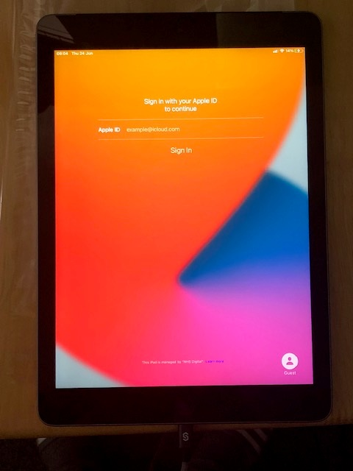

**Step 9**

Your device will prompt you to press the ‘Home’ button to enter the device. Press the Home button on your device.

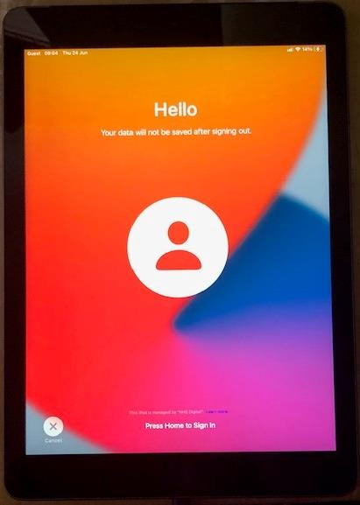

**Step 10**

Your device will now begin installing the required applications. This may take a few minutes.

You do not need to do anything at this step.

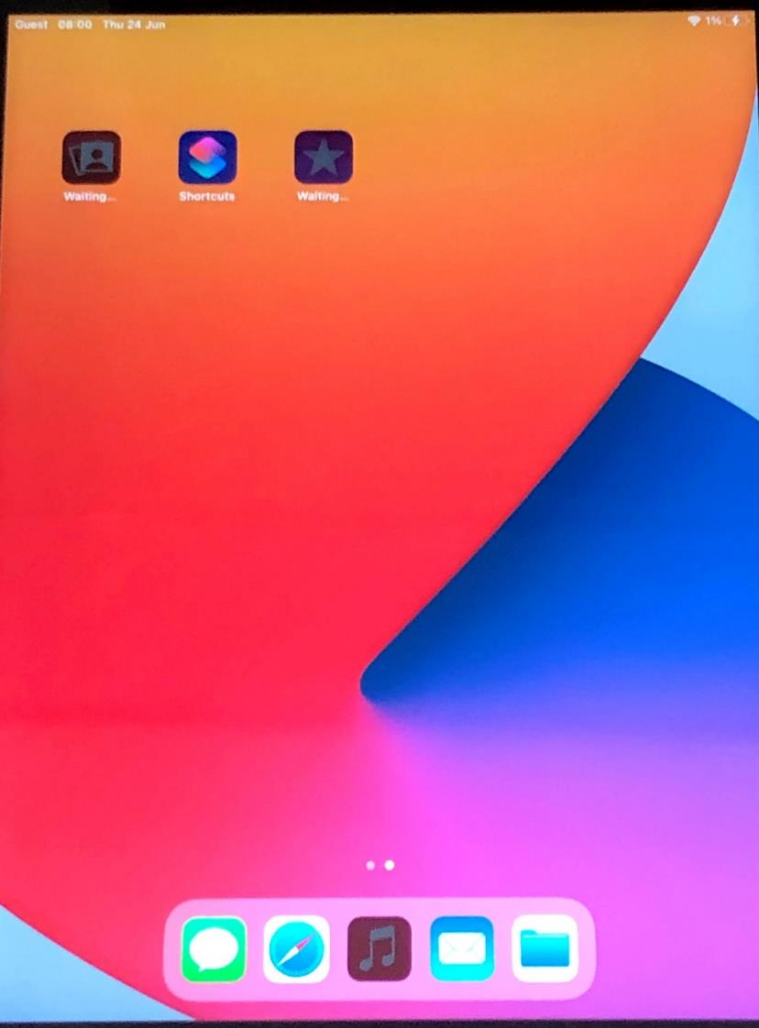

**Step 11**

To end the session, you will need to lock your device and then reopen it. You will be prompted to sign out. Select ‘Sign Out’ which should be shown in the bottom right hand corner of your device’s screen.

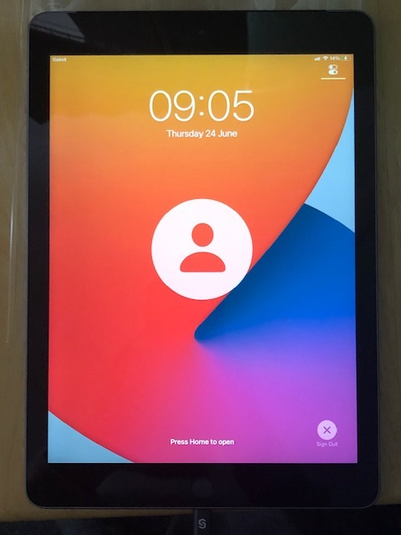

**Step 12**

You will be asked to confirm that you want to end the session. If you want to end the session, select ‘Sign Out’. If you do not want to end the session, you can select ‘Cancel’.

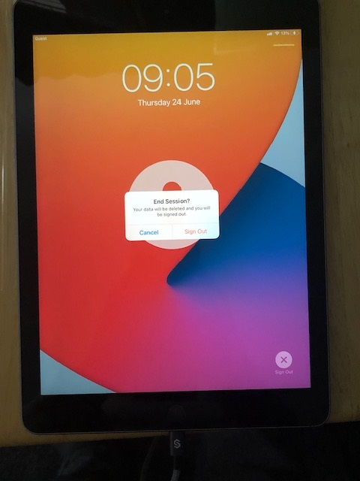

**Step 13**

If you choose to end the session on Step 12, your device will have ended your session and will now show the screen below. A new session can now be started.

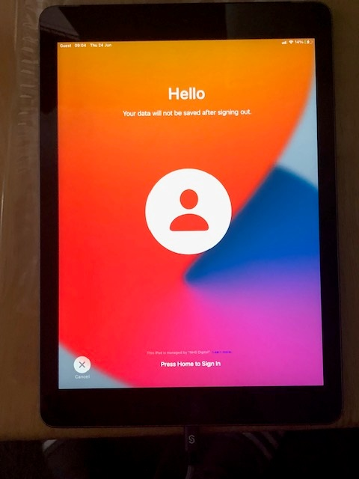

# 4. iOS/iPadOS Frequently Asked Questions (FAQs)

Below is a list of common or frequently asked questions which users of Intune-enrolled iOS/iPadOS devices may ask.

The purpose of these FAQs is to support you, as an End User, to perform some simple technical troubleshooting which should reduce the amount of issues you need to raise with a Local Administrator.

Please refer to these FAQs if you encounter an issue using your device before raising the issue with a Local Administrator.

If these FAQs do not provide you with the answer/s you need or the recommended action/s have not resolved your problem, then please contact your Local Administrator who will be able to provide additional assistance.

|  |  |
| --- | --- |
| Question | Answer / Recommended Course of Action |
| Why isn’t my device turning on? | If your device is not turning on, it could mean that your device battery level is too low. In this instance, you should plug in your device into a power socket. If your device is still having issues turning on, there may be a hardware issue and your device will need to be replaced.  Please contact your Local Administrators. |
| How do I enrol my IOS devices into Intune? | Please follow the steps outlined in Section 2 & 3 of this document. |
| IS VPN Connectivity required during Set Up? | No. VPN connectivity will not be required to login to your device or to access applications. |
| What is Guided Access Mode? | Guided Access mode limits the ability to control certain functions of your device such as the home button, volume, touchscreen etc.  Once you have completed the Apple setup wizard, your device will start in Guided access mode while the Company Portal app installs in the background. This is designed to make sure that you enrol your device into NHS Intune before you first use it. |
| Which applications are pre-installed? | Google Chrome and the Company Portal app will be pre-installed on the device. All other stock Apple applications (pre-built) will also be available on the device. |
| Will I be able to use In-Private browsing mode? | InPrivate browsing mode will be available on the iPad as an option. However, this won’t be enforced as the iPad is configured with a guest account and it will wipe all your data once you log out. |
| Why can’t I use Siri? | As part of the baseline build Siri has been disabled from the lock screen. Siri is still accessible once the device is unlocked. |
| How do I switch/connect to a wireless network? | Please follow the steps below to switch your Wi-Fi connection.   1. Open the Wi-Fi settings by swiping down from the upper-right of the screen   2. Tap and hold the Wi-Fi symbol to turn on Wi-Fi  3. Select the network you wish to connect to  You may need to enter a password for the Wi-Fi network to connect. You should be able to access this locally. |
| Why won’t my IOS device connect to Wi-Fi? | Check your network settings to make sure your device has Wi-Fi enabled and is connected to a Wi-Fi network. Also check that your device is not on airplane mode. Swipe down from the top of your screen, which will open your device’s notification panel, then swipe down from the notification panel to reveal the Quick Settings Menu. On the Quick Settings Screen, you can toggle airplane mode ‘off’ if it is ‘on’. |
| Why has my device disconnected from Wi-Fi? | Check that your device is not on airplane mode. You can do this by opening the Control Centre. Swipe down from the top right side of the screen to open the Control Centre. Check your network settings to make sure your device has Wi-Fi enabled and is connected to a Wi-Fi network. |
| What applications are already installed? | A list of managed applications can be viewed below.  **Disclaimer:** Some stock IOS applications (pre-built) may be removed during the fully managed enrolment process.   * Google Chrome * Edge * Company Portal App * Intune Portal App * Authenticator |
| Can I access my Outlook on my device? | Outlook will not be installed as part of the baseline build so if you need to check your Outlook/email, you can do this via the Internet using the web browser. |
| How do I sync my device via the Company Portal? | Open the Company Portal or Intune Portal App on your device, and then select your phone as the device you wish to sync. You should then be able to click ‘Sync’ to complete this step. |
| Why won’t my device sync via the Company Portal? | If you have followed the instructions above to sync the phone and syncing is not working, please contact your LA/s. |
| Why can’t I install applications from the App store? | Downloading applications has been disabled in the baseline configuration. If you require an application on the device, please contact your LA/s. |
| Why can’t I access iTunes/App Store? | This has been disabled as part of the baseline configuration. If you require additional apps, please contact your local LA/s. |
| How do I access web applications? | Web applications will be accessible through the Google Chrome browser. |
| Why can’t I download/play local media? | This has been locked down as part of the baseline configuration. However, media content will still be able to be played through the Google Chrome browser. |
| Why won’t my files open locally? | The file may be trying to open in an application which is not installed locally. Please use web browser alternatives if required. |
| Why can’t I open PDFs? | Adobe PDF reader is not pre-installed on the device. Please use web alternatives if required. |
| Why can’t I reset my device? | Fully Managed IOS devices can only be reset by LAs.  If you require your device to be reset, please contact your LA/s. |
| How do I connect peripherals (smartcards, barcode scanners etc) to my IOS device? | Barcode scanners and other essential work-related accessories will be able to connect to your device via Bluetooth in device settings. |
| Why is my device crashing? | If your device is crashing regularly, there may be a hardware fault with your device.  Please contact your LA/s, as they will be able to assess the issue and work to resolve it. If there is a hardware fault, the device will need to be replaced by your LA/s. |
| How do I close an application which has crashed? | To close an application, double click the home button and swipe the application you wish to close off the screen. To close an application that has crashed or frozen, follow the same process. If the crashed/ frozen application will not close after several attempts, contact your LA/s. |
| Why can’t I take screenshots? | If you are attempting to take a screenshot in a managed app you may see an error saying, “*Couldn’t save screenshot, taking screenshots isn’t allowed by the app or your organisation*.”  Fully managed devices do not allow you to take screenshots in managed apps which may hold company data. Other unmanaged applications should not cause any issues. |
| Will I be able to use an e-Sim? | You will be able to use an e-Sim however you will not be able to make any modifications in the settings app since this has been blocked as a part of the baseline configuration. |
| Why is my battery draining? | If the device battery is draining, it could be running a background process such as a software/ application update. Remember to close all applications after use, as having multiple applications running in the background can contribute to battery drain. If battery drain is a persistent issue, please contact your LA/s. |

# 6. Details of Organisation-specific Support

If you have questions about any of the content in this guide, are encountering issues following the step-by-step enrolment guides or have a technical issue which you cannot resolve by following a course of action recommended in the FAQs, please contact:

[*Insert Local Administrator details/email address*]

And/or

[*Insert mailbox address*]